Patient Survey 2014

The Patient Reference group (PRG) have been emailed our first edition of the practice questionnaire; we are a new group and are actively trying to recruit committee members so that we may take the group to the next stage. Additional questionnaires have been pinned on the PPG notice board for those patients wishing to take away and complete however, they are also being handed out to patients attending the surgery. This ensured that patients without internet access could also have input into the survey. We are still waiting for the questionnaires to be returned.

As a surgery we wanted to question patients as to how they currently book appointments and how they would like to book following a few comments about using the full online facilities. We felt it was important to gain an insight into how the overall booking system works and if it could be improved from the patient’s perspective and to also offer more choice on booking appointments. We have set up a trial system for booking online and information has been displayed in the surgery as well as adding to the prescription messages. This will be monitored and patient feedback will be requested. Currently 425 patients out of 7177 are actively using the online system despite information being displayed within the surgery. We will draw patient attention to the service in the next patient newsletter and step up advertising around the surgery and at reception.

We have also asked questions on patients experience at Reception. We wanted to know how patients felt about privacy while talking to reception staff, could they be overheard by other patients and how they feel the staff respected their privacy. We asked how long patients waited before they were seen by the clinical staff.

Section C of the questionnaire was aimed at the patient experience when they came to see the GP. We felt it important to seek information on how long the patients had to wait to see a particular GP and how well the GP listened to their problems, if patients felt they were being involved in the decision making on their treatment plan etc. We also decided to seek similar information regarding the practice nurses appointments and the care offered by the nurses for those patients with long term health problems such as Diabetes or Asthma.

There is additional free space for patients to give their honest comments without being directed and thus gives honest feedback as to the services received.

Any patient registered at the practice can join the reference group by informing the Assistant Practice Manager. We are making a lot of effort to ensure the group is representative of the whole list by approaching people who are from an under represented group. We have had notices up in the waiting room asking people to join the PRG and also placed an information flyer in the new registration pack.

Type of patients on the reference group

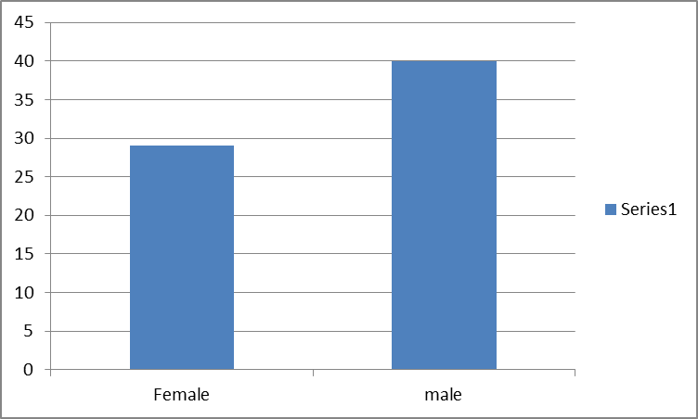

Type of patients registered with the practice

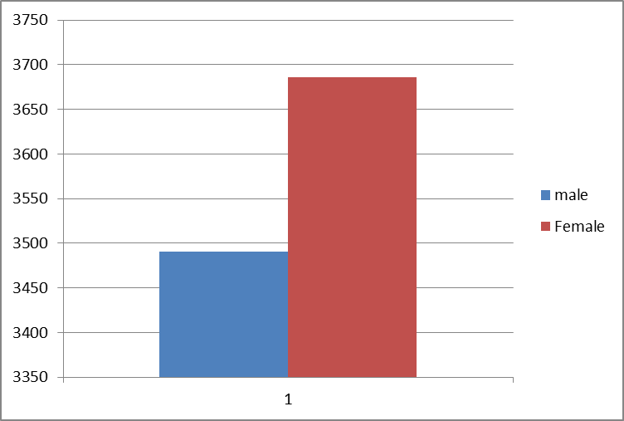

We are actively still recruiting from the total patient population.

The practice has a predominantly White British list. However, we are trying to actively encourage patients from other ethnicities to join the group to ensure we have a fully representative group.

The above graphs demonstrate that the PRG is not truly reflective of the actual list. This is because it does not represent the views of the full age range brackets. We are actively still recruiting and trying to develop the group.

In March 2014 patients on the PRG were contacted and asked to complete the questionnaire. These returns are still pending. Additional patients are being asked in the waiting room. This ensured a full range of patients are approached and the return will be reflective of the patients on the practice list.

The next stage is for the pending questionnaires to be reviewed and to make suggestions as to what could be added to an action plan for the practice to move forward. We will print the report and put it in the waiting room asking for comments. These results will become the basis of our first PPG meeting once a committee has been formed.

We will of course publish the action plan on the website shortly and thank all the patients for taking the time to fill in the questionnaire; we really appreciate your help.

Thank you

For information only

The practice is open from 8am until 18:30pm Monday to Friday. During this time the telephone lines and doors are open, we do not close for lunch.

We also provide a late surgery on a Tuesday and Wednesday where the practice is open until 20:00pm for pre-booked GP consultations but the telephone is transferred to out of hours service at the normal time of 18:30pm.

If you require any information please contact reception who will be able to

This report and the completed action plan will be shared with the Patient Participation Group, The Patient Reference Group, with the GPs and staff. It will be displayed on the website and it will be printed and displayed in the waiting room and on the practice notice board. It will also be posted to those patients who took part in the survey who do not have email access. We will also send a copy to our local Healthwatch and Clinical Commissioning Group.

